1. What is Software? What is Software Engineering?

-> Software is a Collation of Intrution,Informmation and Data

-> Software Engineering is process of Designing,Developing etc.

2. Explain Types of Software?

-> System Software, Application Software and Programme Software.

(i) System Software:-

-> Oprating System– It Maneges The Computur’s Hardware Resourcs and Provides Aninterface for user to interact with Software Applications. Ex. Windows, linux.

(ii) Application Software

1. Desktop Application – Word processing Software

Ex. Ms Word, Open Office etc.

1. Mobile Application – Which are only working on Mobile

Ex. Telegram , Facebook , Instagram , whattapp etc.

1. Web Application – Web Application are Also Known as Web Browser

Ex. Chrome , Edge , Mozilla etc.

(iii) Programming Software – It is use to execute (run) the Programm

(1) Compiler

(2) Interpreter

3. What is SDLC? Explain each phase of SDLC.

-> Full Form of SDLC(Software Development Life Cycle)

-> SDLC consists of various phases, such as planning, design, coding, testing, and deployment .

(i) ) Planning : - It is the initial phase of SDLC.

-> To create a software first we need to know what is the requirement of customer or client.

(ii) Analysis : - In this phase involves the understanding about end-user needs and analysis of all requirement of customer.

-Analysisabout market strategy which software or product is moving faster.

(iii) Design : - In this phase the developer create a system architecture and base on that designed it.

-> It involves the all basic of data structure that not affect the software.

-> the software is design as the customeer requirement.

(iv) Implementation : - In this phase , the developer create a code that software occurs.

-> developer write a code than test the writing code that know the the code is perfectly fit on the their design or not.

(v) Testing : - In this phase, The software tested for bugs , errors , overloading and other issues.

-> different testing method are used. e.g., unit testing,integration testing,system testing,etc.

(vi) Maintenance : - After all phase will complete than it is enter. this phase involves the ongoing support , updates , solution of bugs or some error after some time will pass.

-> It ensure that the software will reliable and up to date.

4. What is DFD ? create DFD diagram on Flipkart.

-> DFD that means Data Flow Diagram.

-> DFD is the graphical representation of how data flows within the system.

ex. data where store, data sources. - creating a DFD that require elements:

-> External Entity

-> Process

-> Data flow

-> Data store

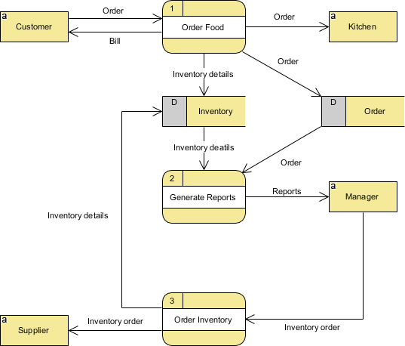

5. What is Flow Chart ? create a flow chart to make a addition of two numbers.

-> Flow chart is a graphical representation of a algorithm.

-> Non Software engineer is make or understand the algorithm using the flowchart.

SUM=N1+N2

PRINT SUM

INPUT N1,N2

Start : there is oval symbol for represent the start and end.

Flow : there is a arrow symbol for represent the flow of data.

Condition : There is diamond symbol to represent the condition.

Process : There is rectangle symbol for represent the process during the program.

Pageup : For representing of continuous page there is a oval symbol is used.

6. What is Use case diagram ? create a use case on bill payment od paytm.

-> Use case diagram is that the graphical representation of what customer or website has to access the the data or we can say what process can access by the some other such as user,website,etc.

-> A use case focus on the functionality of system.

